Use this reference to change a student’s program of study

INSTRUCTIONS

- Log into Workday and enter and click the student’s name in the search bar.

- In the student’s record, click “Academics” in the left-hand menu. Click the “Overview” tab.

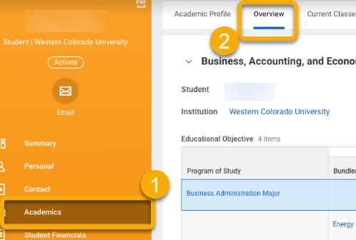

- In the Overview tab, locate the student’s in-progress program of study that will be changed. Scroll to the right and click the “Request” button.

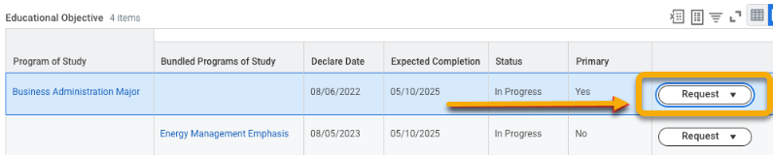

In this example, the student is changing from a business administration major to a new major. The student’s energy management emphasis will stay the same.

- A drop-down menu will appear. Click “Change Program of Study Record”
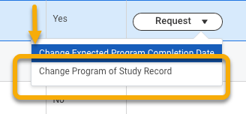

- On the Change Program of Study Record page, you will use the “+” symbol and “-” symbol to add or remove rows.

  - In the Change Program of Study table, remove the existing program study and add the new program of study. If you are adding an additional program of study for a double major, add an extra row.

  - In the Is Primary column, check the new program of study as primary. Note:Only one program of study can be marked as primary.

  - In the Expected Completion Date column, match the expected completion date seen in the table above

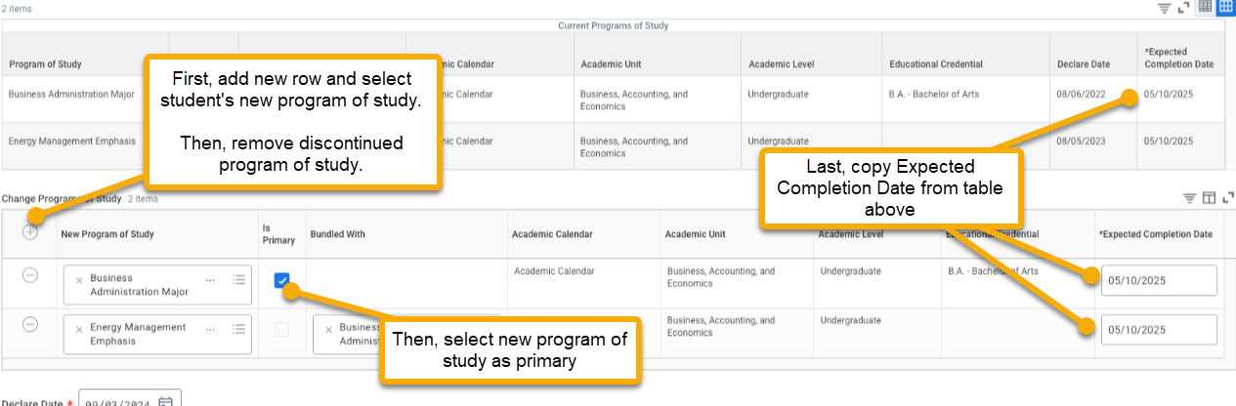

- Leave Declare Date as is.

- Click “Submit”.

